Rice Grain Quality Analysis Using CNN

Done by-

NAME : LOKESH.S.B

III RD YEAR BE COMPUTER SCIENCE

REG NO.-211521104081

**A B S T R A C T**

Rice is a staple food crop for millions of people worldwide, and the quality of the rice grains is a critical factor in determining its market value and consumer acceptance. Traditional methods of grading and classifying rice grains are time-consuming and subjective, leading to inconsistencies and errors in the final product. In recent years, deep learning (DL) techniques have shown great promise in automating the process of rice grain quality analysis. In this study, we developed a DL-based approach for rice grain quality analysis using a large dataset of rice grain images. The DL model was trained to classify rice grains based on various quality parameters such as size, shape, colour, texture, and defects. The results showed that the DL model could accurately classify rice grains with a high degree. Furthermore, the DL-based analysis provided insights into the underlying physical and chemical properties of the rice grains, which can be used to optimize production and processing methods.

# INTRODUCTION

Rice is one of the most important staple crops in the world, providing a significant source of nutrition for billions of people. The quality of rice grains is crucial for ensuring food security and economic development. Traditional methods of rice quality analysis are time-consuming, labour-intensive, and subjective, involving visual inspection by human experts. This can lead to inconsistencies in quality assessment, which can have significant economic consequences for farmers, processors, and consumers. In recent years, deep learning (DL) has emerged as a promising tool for automated and objective quality analysis of agricultural products, including rice grains. DL is a subfield of machine learning that involves training artificial neural networks on large datasets to learn patterns and features that can be used to classify, segment, or detect objects in images or other data types. DL-based approaches for rice grain quality analysis can provide a more accurate, efficient, and objective method for grading and classifying rice grains based on various quality parameters such as size, shape, colour, texture, and defects. This can help farmers and processors to optimize their production and processing methods, reduce waste, and ensure consistent quality of the final product. Additionally, DL-based quality analysis can also provide insights into the underlying physical and chemical properties of rice grains, which can further inform improvements in the rice production and processing industry. In this study, we present a DL-based approach for rice grain quality analysis, which involves training convolutional neural networks (CNNs) on a large dataset of rice grain images to classify and grade grains based on various quality parameters. We demonstrate the effectiveness of our approach through extensive experiments on real-world datasets, showing that DL-based approaches can achieve high accuracy and performance for rice grain quality analysis. The results of this study have important implications for the rice production and processing industry, as well as for the broader field of agricultural quality analysis using DL.In this study, we present a DL-based approach for rice grain quality analysis, which involves training convolutional neural networks (CNNs) on a large dataset of rice grain images to classify and grade grains based on various quality parameters. We demonstrate the effectiveness of our approach through extensive experiments on real-world datasets, showing that DL-based approaches can achieve high accuracy and performance for rice grain quality analysis. The results of this study have important implications for the rice production and processing industry, as well as for the broader field of agricultural quality analysis using DL.

### Objective

The objective of using deep learning (DL) for rice grain quality analysis is to develop an accurate and efficient method for grading and classifying rice grains based on various quality parameters such as size, shape, colour, texture, and defects. DL models can be trained on large datasets of rice grain images to learn the patterns and features that distinguish high-quality grains from lower-quality grains. This can help farmers and processors to optimize their production and processing methods, reduce waste, and ensure consistent quality of the final product. Additionally, DL-based quality analysis can also provide insights into the underlying physical and chemical properties of rice grains, which can further inform improvements

# REQUIREMENTS SPECIFICATION

### Hardware Requirements:

System : Intel core i5 Processor.

Hard Disk : 128 GB

Monitor : 15’’ LED

Input Devices : Keyboard, Mouse

Ram : 8 GB

### Software Requirements

Operating system : Windows 8,10

Coding Language : Python

Front end react : React Js

Python and related libraries. Dataset is obtained fromKaggle.

# SYSTEM ARCHITECTURE

## EXISTING SYSTEM

In existing system uses a deep CNN to analyse rice quality based on its appearance, including colour, shape, and texture. The system was trained on a large dataset of rice images and achieved high accuracy in identifying rice quality. In existing system demonstrate the potential of deep learning CNNs for rice quality analysis, and they could have significant applications in the food industry for quality control and assurance.

##### Disadvantages:

* + - Time consuming.
    - Dependence on technology.
    - Lack of flexibility

## PROPOSED METHOD

In proposed system using a Dense net model for rice quality analysis can provide an accurate and efficient way to classify different types of rice based on their quality. This system can be used by rice producers, processors, and consumers to ensure consistent quality and make informed decisions about rice selection.

A system for rice grain quality analysis using Resnet could provide a fast and accurate way to classify rice grains based on their quality, which could help rice mills and agricultural research institutes make more informed decisions.

## BLOCK DIAGRAM

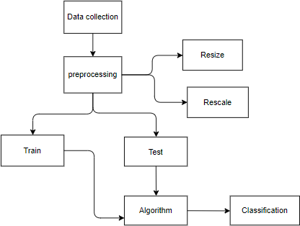

##### Advantages:

* + - Reduce costs
    - High safety
    - Increase the man power.
  1. ***ARCHITECTURE***

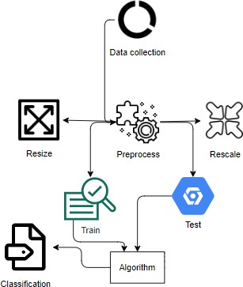

# MODULES

## USER

**Data:** The data collected from Kaggle the user will provide the system with data.

**Input image:** The user must then provide an image in order for the outcome to be accurate.

**View Result:** The user could therefore view their results from the system

## SYSTEM

**Preprocess:** The data provided by the user will first undergo preprocessing by the system.

**Data split:** To deliver results to the user, the system will divide the provided data.

**Algorithm model training:** The algorithm model will then be trained by the system.

## INPUT DESIGN

In an information system, input is the raw data that is processed to produce output. During the input design, the developers must consider the input devices such as PC, MICR, OMR, etc.

Therefore, the quality of system input determines the quality of system output. Well-designed input forms and screens have following properties −

* + - It should serve specific purpose effectively such as storing, recording, and retrieving the information.
    - It ensures proper completion with accuracy.
    - It should be easy to fill and straightforward.
    - It should focus on user’s attention, consistency, and simplicity.
    - All these objectives are obtained using the knowledge of basic design principles regarding
    - What are the inputs needed for the system?
    - How end users respond to different elements of forms and screens.

##### Objectives for Input Design:

The objectives of input design are −

* + - To design data entry and input procedures
    - To reduce input volume
    - To design source documents for data capture or devise other data capture methods
    - To design input data records, data entry screens, user interface screens, etc.
    - To use validation checks and develop effective input controls.

## OUTPUT DESIGN

The design of output is the most important task of any system. During output design, developers identify the type of outputs needed, and consider the necessary output controls and prototype report layouts.

##### Objectives of Output Design:

The objectives of input design are:

* + - To develop output design that serves the intended purpose and eliminates the production of unwanted output.
    - To develop the output design that meets the end user’s requirements.
    - To deliver the appropriate quantity of output.
    - To form the output in appropriate format and direct it to the right person.
    - To make the output available on time for making good decisions.

# 5.UML DIAGRAMS

UML stands for Unified Modelling Language. UML is a standardized general-purpose modelling language in the field of object-oriented software engineering. The standard is managed, and was created by, the Object Management Group.

The goal is for UML to become a common language for creating models of object-oriented computer software. In its current form UML is comprised of two major components: a Meta-model and a notation. In the future, some form of method or process may also be added to; or associated with, UML.The Unified Modelling Language is a standard language for specifying, Visualization, Constructing and documenting the artefacts of software system, as well as for business modelling and other non-software systems. The UML represents a collection of best engineering practices that have proven successful in the modelling of large and complex systems.

#### GOALS:

The Primary goals in the design of the UML are as follows:

1. Provide users a ready-to-use, expressive visual modelling Language so that they can develop and exchange meaningful models.
2. Provide extendibility and specialization mechanisms to extend the core concepts.
3. Be independent of particular programming languages and development process.
4. Provide a formal basis for understanding the modelling language.
5. Encourage the growth of OO tools market.
6. Support higher level development concepts such as collaborations, frameworks, patterns and components.
7. Integrate best practices.

#### USE CASE DIAGRAM

▶ A use case diagram in the Unified Modeling Language (UML) is a type of behavioral diagram defined by and created from a Use-case analysis.

▶ Its purpose is to present a graphical overview of the functionality provided by a system in terms of actors, their goals (represented as use cases), and any dependencies between those use cases.

The main purpose of a use case diagram is to show what system functions are performed for which actor. Roles of the actors in the system can be depicted

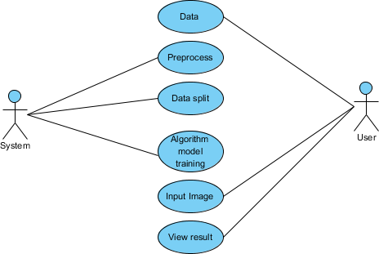

## CLASS DIAGRAM

In software engineering, a class diagram in the Unified Modeling Language (UML) is a type of static structure diagram that describes the structure of a system by showing the system's classes, their attributes, operations (or methods), and the relationships among the classes. It explains which class contains information

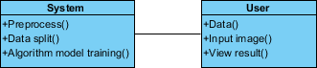

## SEQUENCE DIAGRAM

▶ A sequence diagram in Unified Modeling Language (UML) is a kind of interaction diagram that shows how processes operate with one another and in what order.

▶ It is a construct of a Message Sequence Chart. Sequence diagrams are sometimes called event diagrams, event scenarios, and timing diagrams

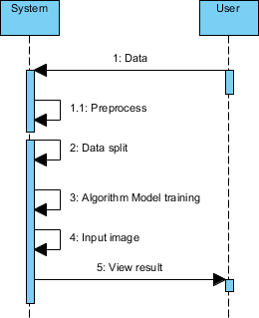

## COLLABORATION DIAGRAM:

In collaboration diagram the method call sequence is indicated by some numbering technique as shown below. The number indicates how the methods are called one after another. We have taken the same order management system to describe the collaboration diagram. The method calls are similar to that of a sequence diagram. But the difference is that the sequence diagram does not describe the object organization whereas the collaboration diagram shows the object organization.

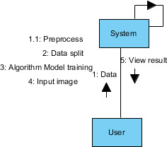

# SOFTWARE INSTALLATION FOR MACHINE LEARNING PROJECTS:

1. To download and install Python visit the official website of Python <https://www.python.org/downloads/> and choose your version.

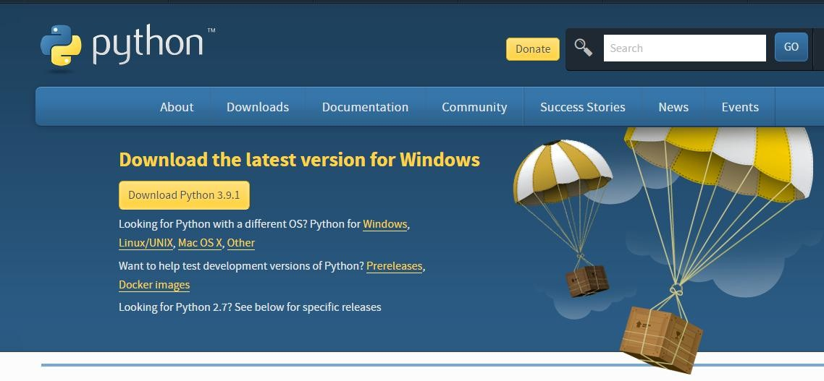

1. Once the download is complete, run the exe for install Python. Now click on Install Now.
2. You can see Python installing at this point.
3. When it finishes, you can see a screen that says the Setup was successful. Now click on "Close".

##### Installing PyCharm:

* 1. To download PyCharm visit the website <https://www.jetbrains.com/pycharm/download/> and click the "DOWNLOAD" link under the Community Section.



* 1. Once the download is complete, run the exe for install PyCharm. The setup wizard should have started. Click “Next”.
  2. On the next screen, Change the installation path if required. Click “Next”.
  3. On the next screen, you can create a desktop shortcut if you want and click on “Next”.
  4. Choose the start menu folder. Keep selected Jet Brains and click on “Install”.
  5. Wait for the installation to finish.
  6. Once installation finished, you should receive a message screen that PyCharm is installed. If you want to go ahead and run it, click the “Run PyCharm Community Edition” box first and click “Finish”.
  7. After you click on "Finish," the Following screen will appear.

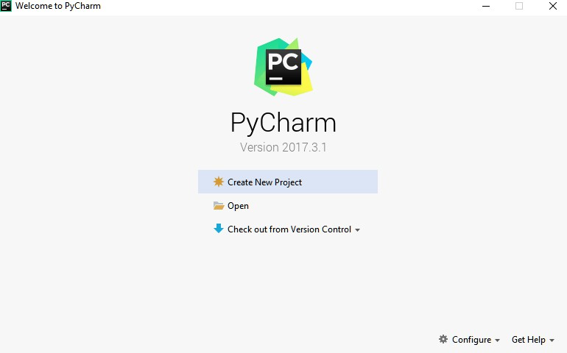

* 1. You need to install some packages to execute your project in a proper way.
  2. Open the command prompt/ anaconda prompt or terminal as administrator.
  3. The prompt will get open, with specified path, type “pip install package name” which you want to install (like NumPy, pandas, sea born, scikit-learn, Matplotlib, Pyplot)

Ex: Pip install NumPy

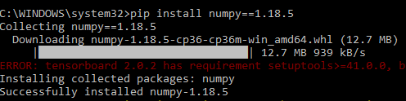

## SYSTEM TESTING

The purpose of testing is to discover errors. Testing is the process of trying to discover every conceivable fault or weakness in a work product. It provides a way to check the functionality of components, sub-assemblies, assemblies and/or a finished product It is the process of exercising software with the intent of ensuring that the

Software system meets its requirements and user expectations and does not fail in an unacceptable manner. There are various types of tests. Each test type addresses a specific testing requirement.

#### TYPES OF TESTS

Unit testing

Unit testing involves the design of test cases that validate that the internal program logic is functioning properly, and that program inputs produce valid outputs. All decision branches and internal code flow should be validated. It is the testing of individual software units of the application .it is done after the completion of an individual unit before integration. This is a structural testing, that relies on knowledge of its construction and is invasive. Unit tests perform basic tests at component level and test a specific business process, application, and/or system configuration. Unit tests ensure that each unique path of a business process performs accurately to the documented specifications and contains clearly defined inputs and expected results.

Integration testing

Integration tests are designed to test integrated software components to determine if they actually run as one program. Testing is event driven and is more concerned with the basic outcome of screens or fields. Integration tests demonstrate that although the components were individually satisfaction, as shown by successfully unit testing, the combination of components is correct and consistent. Integration testing is specifically aimed at exposing the problems that arise from the combination of components.

Functional test

Functional tests provide systematic demonstrations that functions tested are available as specified by the business and technical requirements, system documentation, and user manuals.

Functional testing is centred on the following items:

Valid Input : identified classes of valid input must be accepted. Invalid Input : identified classes of invalid input must be rejected. Functions : identified functions must be exercised.

Output : identified classes of application outputs must be exercised. Systems/Procedures: interfacing systems or procedures must be invoked.

Organization and preparation of functional tests is focused on requirements, key functions, or special test cases. In addition, systematic coverage pertaining to identify Business process flows; data fields, predefined processes, and successive processes must be considered for testing. Before functional testing is complete, additional tests are identified and the effective value of current tests is determined.

#### SYSTEMTEST

System testing ensures that the entire integrated software system meets requirements. It tests a configuration to ensure known and predictable results. An example of system testing is the configuration-oriented system integration test. System testing is based on process descriptions and flows, emphasizing pre-driven process links and integration points.

White Box Testing

White Box Testing is a testing in which in which the software tester has knowledge of the inner workings, structure and language of the software, or at least its purpose. It is purpose. It is used to test areas that cannot be reached from a black box level.

Black Box Testing

Black Box Testing is testing the software without any knowledge of the inner workings, structure or language of the module being tested. Black box tests, as most other kinds of tests, must be written from a definitive source document, such as specification or requirements document, such as specification or requirements document. It is a testing in which the software under test is treated, as a black box .you cannot “see” into it. The test provides inputs and responds to outputs without considering how the software works.

### Unit Testing:

Unit testing is usually conducted as part of a combined code and unit test phase of the software lifecycle, although it is not uncommon for coding and unit testing to be conducted as two distinct phases.

Test strategy and approach

Field testing will be performed manually and functional tests will be written in detail. Test objectives

* + - All field entries must work properly.
    - Pages must be activated from the identified link.
    - The entry screen, messages and responses must not be delayed.

Features to be tested

* + - Verify that the entries are of the correct format
    - No duplicate entries should be allowed
    - All links should take the user to the correct page.

### Integration Testing

Software integration testing is the incremental integration testing of two or more integrated software components on a single platform to produce failures caused by interface defects.

The task of the integration test is to check that components or software applications, e.g. components in a software system or – one step up – software applications at the company level – interact without error.

Test Results: All the test cases mentioned above passed successfully. No defects encountered.

6.3 Acceptance Testing

User Acceptance Testing is a critical phase of any project and requires significant participation by the end user. It also ensures that the system meets the functional requirements.

Test Results: All the test cases mentioned above passed successfully. No defects encountered.

# OUTPUT SCREENSHOTS

ABOUT:

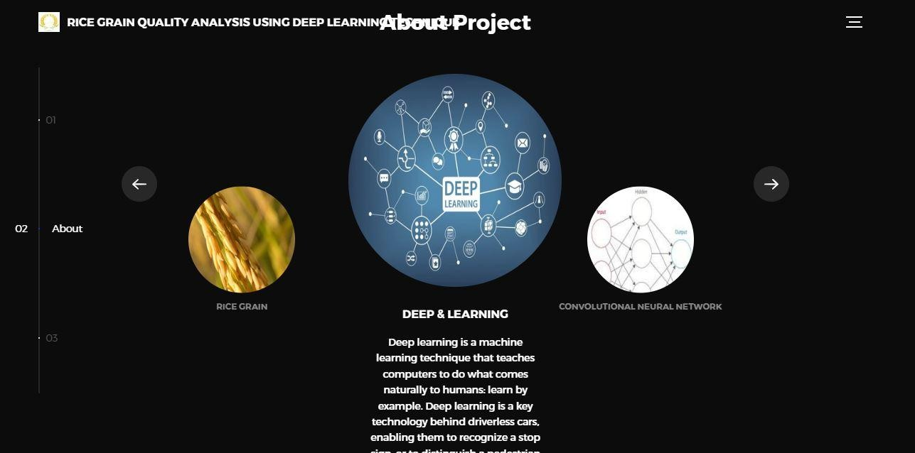

HOME:



IMAGE UPLOAD

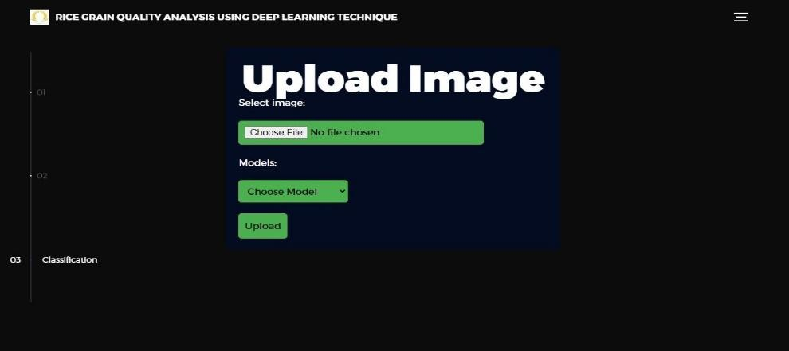

MODE:

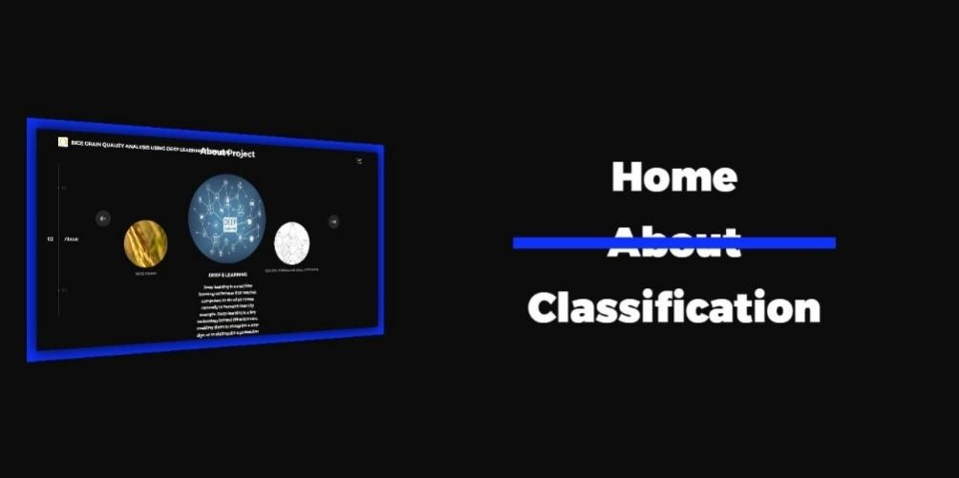

MODEL SELECTION:

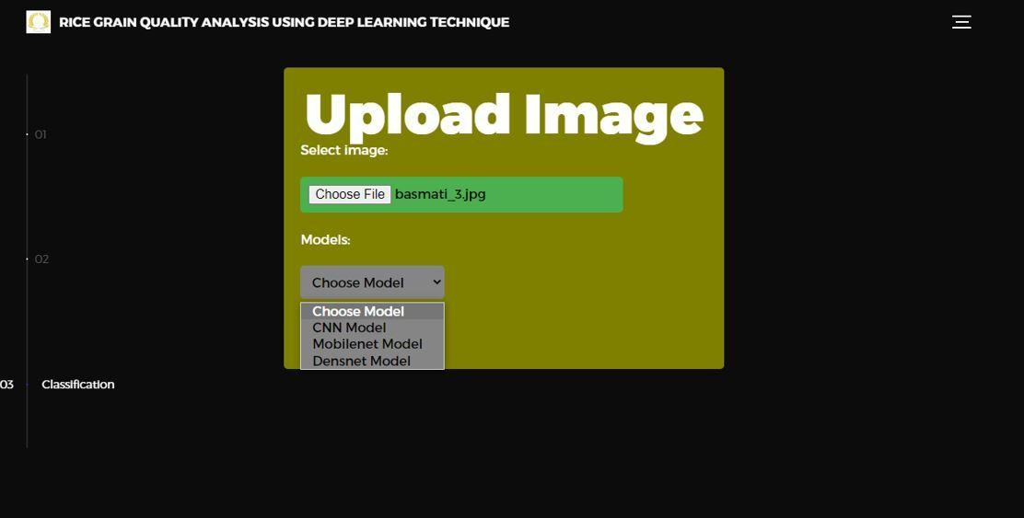

RESULT 1:



RESULT 2:

# CONCLUSION

The use of deep learning techniques, such as convolutional neural networks (CNN), Dense net and Mobile net, have shown promising results in the analysis of rice grain quality. These techniques have been used to detect and classify various parameters, such as the presence of disease, grain size, and shape, which are crucial for determining the quality of rice. The analysis of rice grain quality using deep learning techniques offers several advantages over traditional methods, including higher accuracy, faster analysis, and the ability to analyse a large number of samples simultaneously. This can be especially beneficial for rice breeding programs, where the analysis of a large number of rice samples is necessary to identify desirable traits.

***REFERENCES:***

1. Huang, M., Wang, Z., Lv, H., Jiang, Q., & Huang, D. (2021). Deep Learning Techniques for Rice Quality Evaluation: A Review. Journal of Agricultural and Food Chemistry, 69(5), 1441-1453.
2. Xu, Y., Zhang, S., & Wang, X. (2019). A rice quality detection method based on deep learning. IEEE Access, 7, 131189-131199.
3. Zhang, H., Wang, C., & Zhao, X. (2019). Identification of rice seed varieties using a deep convolutional neural network. PloS one, 14(10), e0223588.
4. Li, D., Li, X., Shi, Y., & Chen, Y. (2020). Identification of rice seed quality based on deep learning technology. Scientific reports, 10(1), 1-8.
5. Liu, H., Chen, L., Zhang, Y., & Huang, Y. (2020). Study on deep learning application in rice quality detection. In 2020 IEEE 9th International Conference on Advanced Logistics and Transport (ICALT) (pp. 186-191). IEEE.
6. Zhang, H., Wang, C., & Zhao, X. (2019). Deep learning-based method for identifying rice seed varieties using seed images. Computers and Electronics in Agriculture, 165, 104995.
7. Xie, S., Zhao, L., Zhang, Y., & Zhang, J. (2020). Deep Learning-Based Rice Seed Quality Inspection Using Multi-Feature Fusion. IEEE Access, 8, 220622-220632.
8. Liu, Y., Zhu, H., Zhou, Y., Wu, G., & Chen, W. (2019). Identification of rice quality by deep learning. Journal of Food Science and Technology, 56(10), 4798-4805.
9. He, Z., Zhou, J., & Zhang, X. (2020). A deep learning approach for assessing the quality of milled rice based on image analysis. Computers and Electronics in Agriculture, 178, 105731.